

**RAMNIRANJAN JHUNJHUNWALA COLLEGE GHATKOPAR (W), MUMBAI - 400 086**

**DEPARTMENT OF INFORMATION TECHNOLOGY**

**2022 - 2023**

**s.Y. B. Sc.( I.T.) SEM iv**

**Paper RJSUITp402 – Embedded Systems**

**Name: Sudesh Dinesh Rajbhar SushilaDevi**

**Roll No. 3067**

**Hindi Vidya Prachar Samiti’s**

**RAMNIRANJAN JHUNJHUNWALA COLLEGE**

**Ghatkopar (W), Mumbai-400 086**

***Certificate***



**This is to certify that Mr./Ms. Rajbhar Sudesh Dinesh SushilaDevi Roll No 3067 of S.Y.B.Sc.(I.T.) class has completed the required number of experiments in the subject of Embedded Systems in the Department of Information Technology during the academic year 2022 - 2023 .**

**Professor In-Charge Co-ordinator of IT Department**

**Prof. Bharati Bhole**

**Prof. Archana Bhide**

**College Seal & Date Examiner**

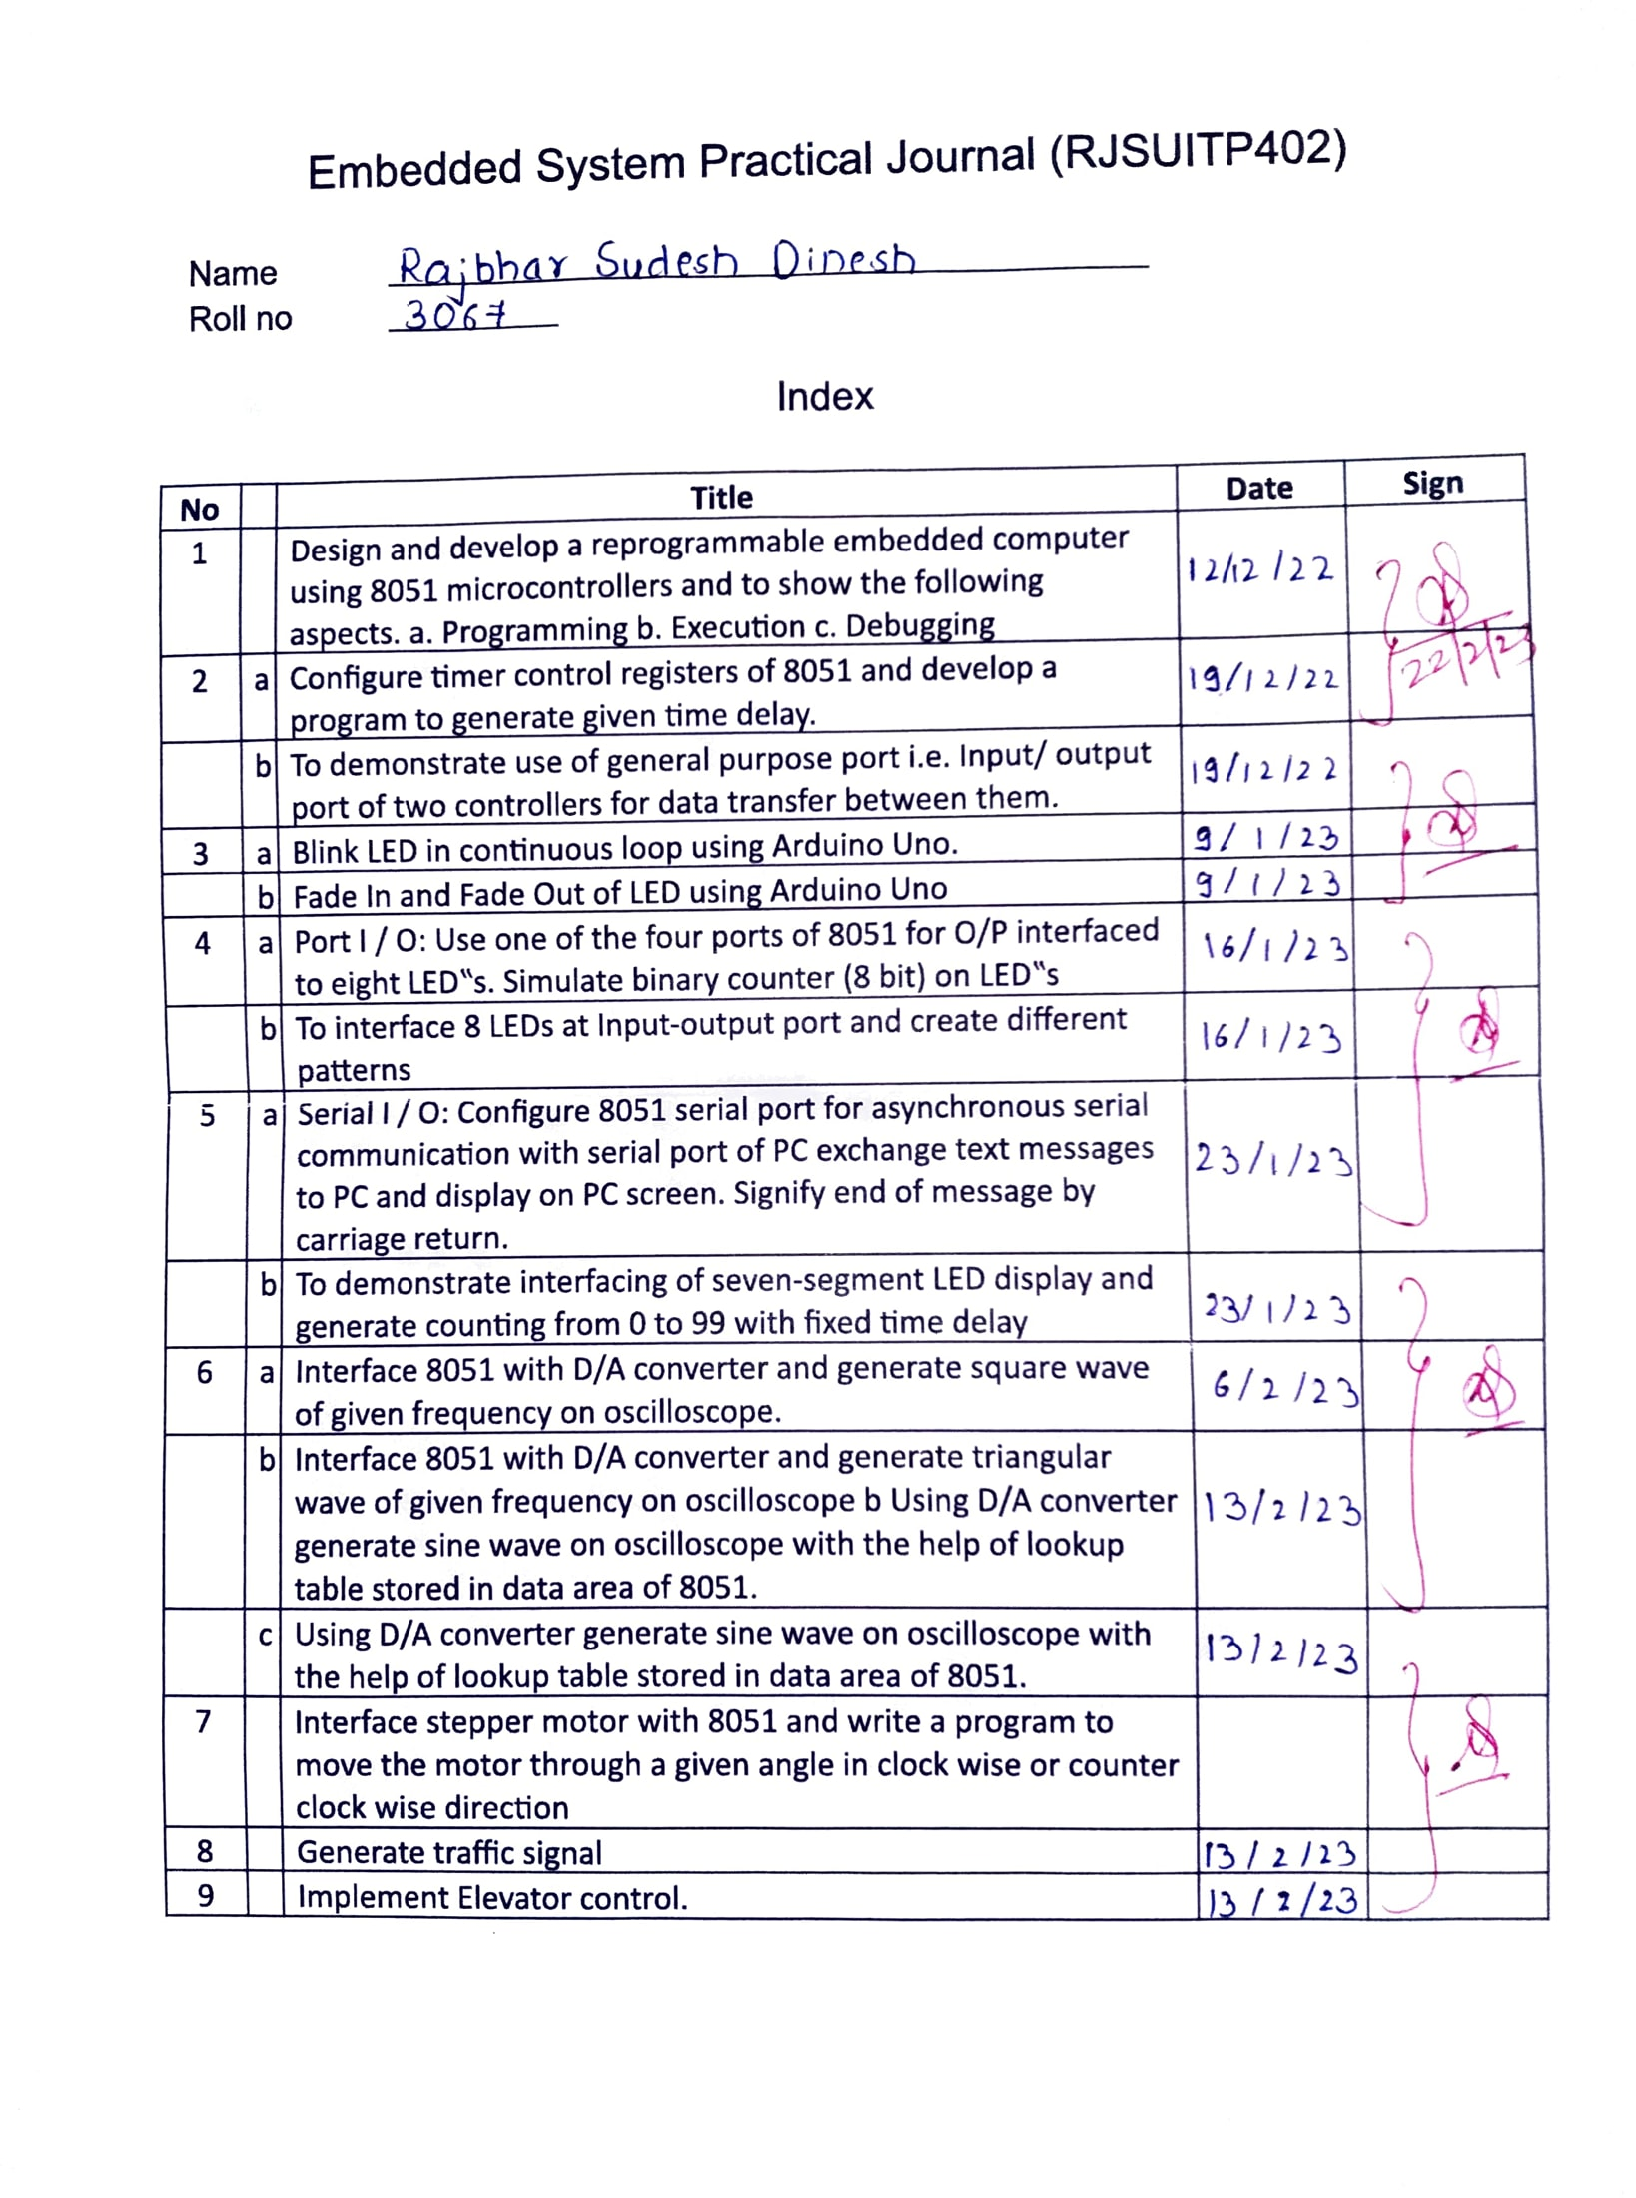

### **Practical 1**

### 

#### Practical 1) Demonstrate the use of reprogrammable computer to perform Programming,Execution and debugging of embedded program using -

a. Programming

b. Execution

c. Debugging

**Introduction to TK Base Trainer Kit**

**Trainer kits used for performing Embedded Systems practical with 8051**

**microcontrollers are TKBase kits. These kits are made up of –**

* CPU specific daughter board.
* Baseboard section
* User Interface

**Baseboard Section includes**

* LEDs
* Four digit 7 segment display
* Hex Keypad
* RS233C serial port

**Software Used**

Execution of Embedded C program is done in two steps. First step is performed at

the host machine. Here, a C program is compiled and built to generate a hex file,

which is assembly code generated by a tool. Several compilers are available for

compiling and linking programs.

**Following are few examples –**

* Crossware Tools for Embedded Development
* μVision 5

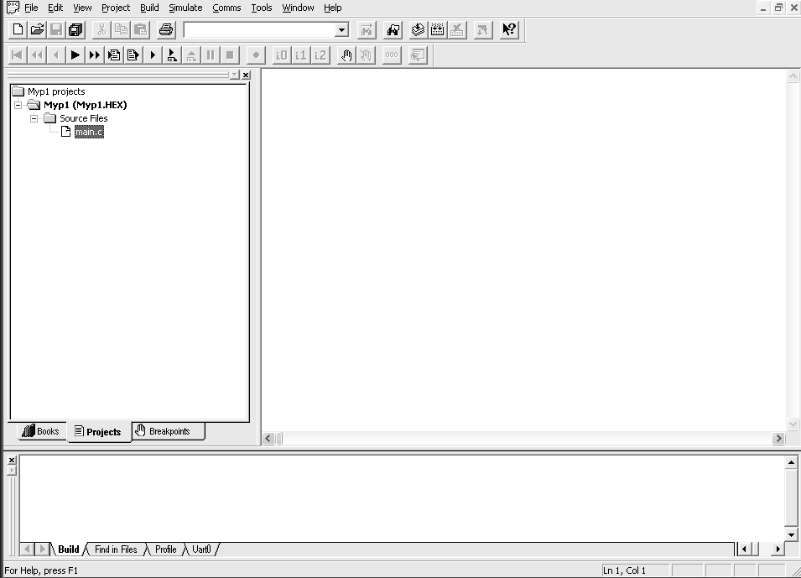

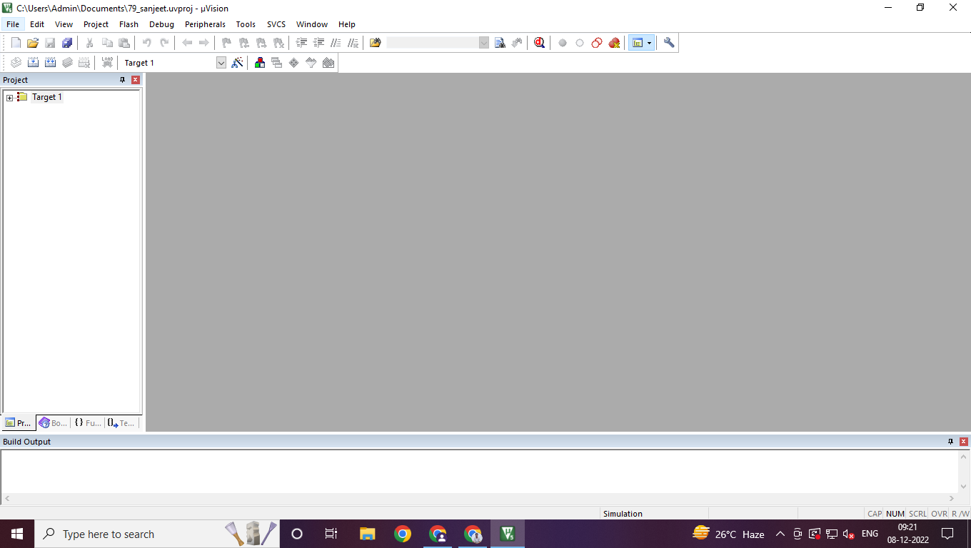

**Working with μvision**

Basic steps in using μvision 5 are as follows –

**Step 1: Create a new project. Name and Save project.**

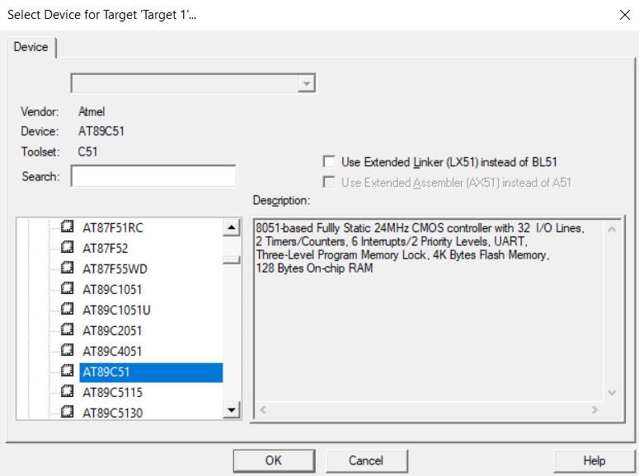

**Step 2:**

**Once the target processor is selected, IDE will automatically add required start up assembly files to the project.**



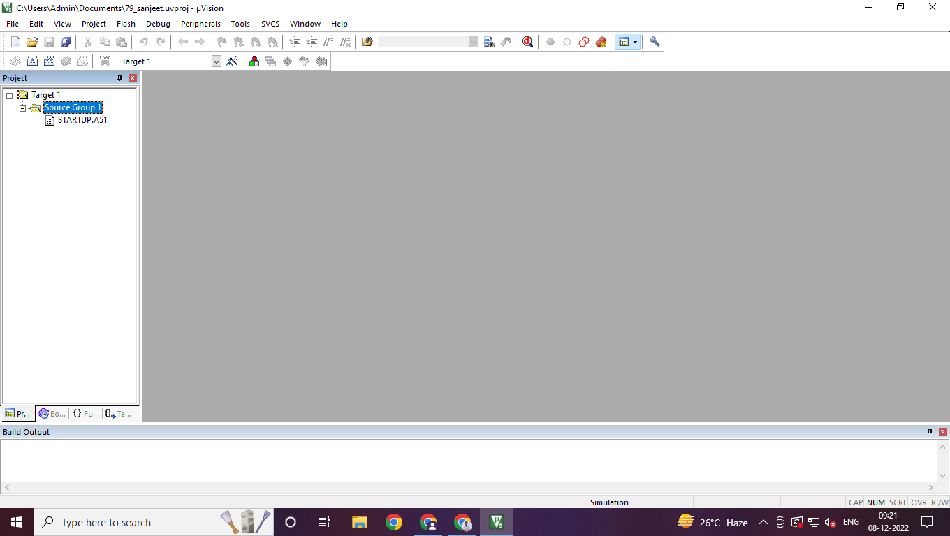

**Step 3**

**Add a new file to the project.**

**One method is to click on the File – New option. Now a text file will be created. It needs to be saved and then added to the project.**

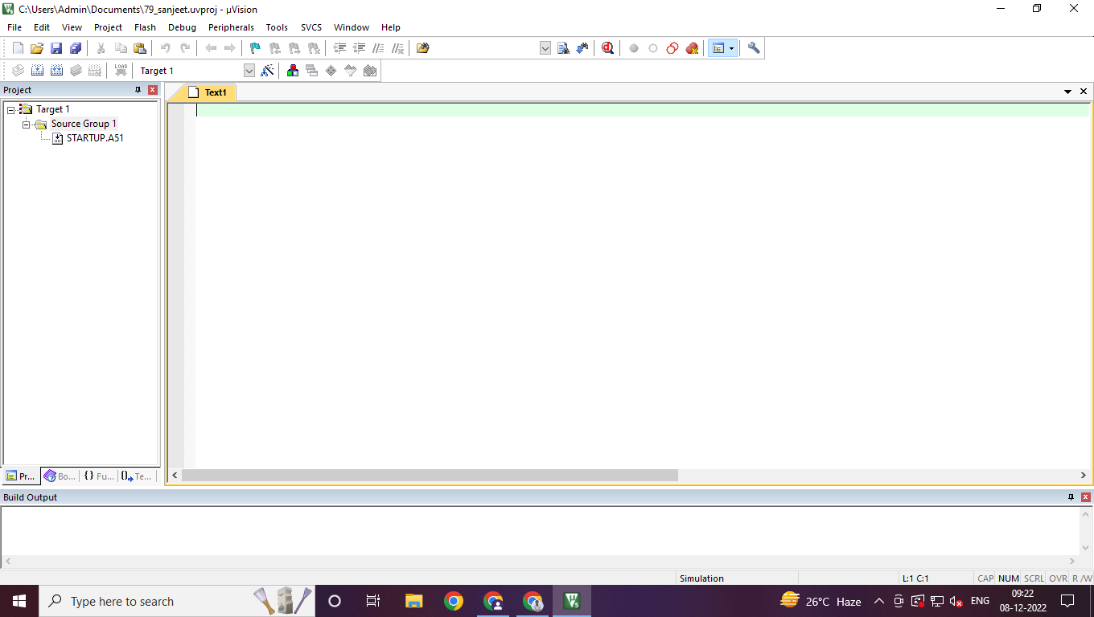

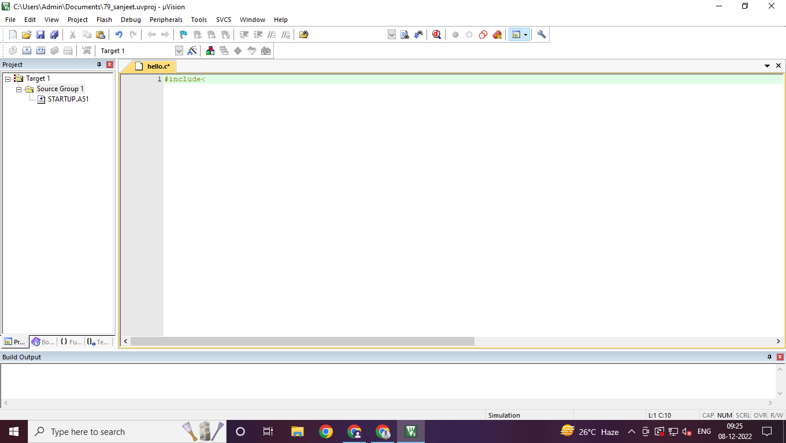

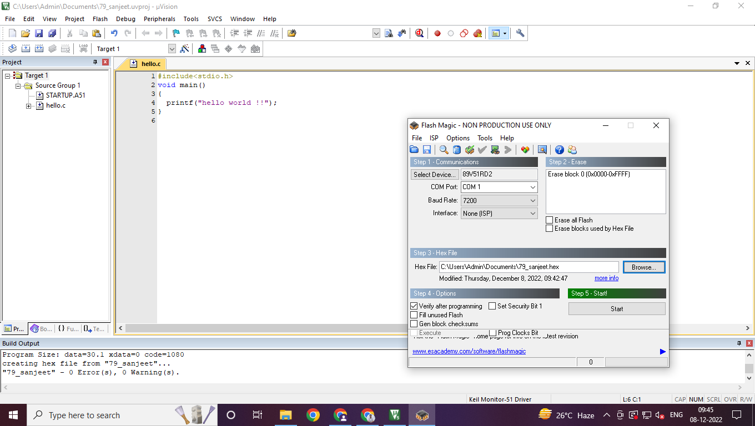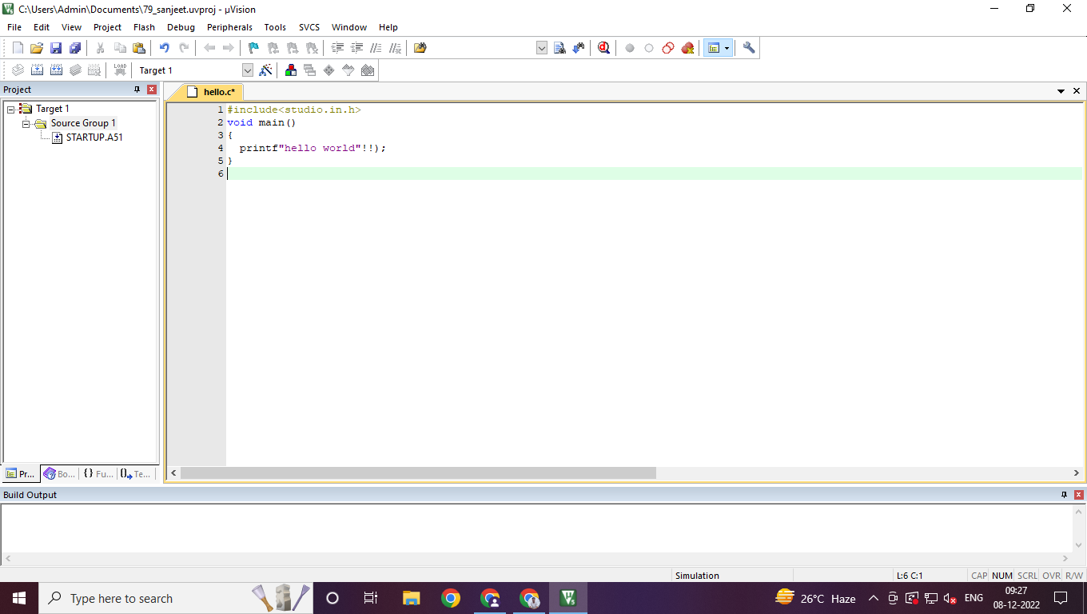

| **#include<stdio.h>**  **void main()**  **{**  **printf(“hello world”!!);**  **}** |
| --- |

**Step 4**

**Target must now be configured**.

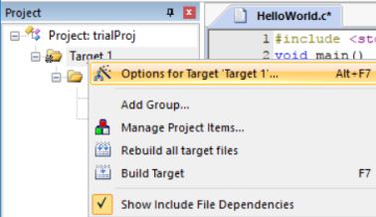

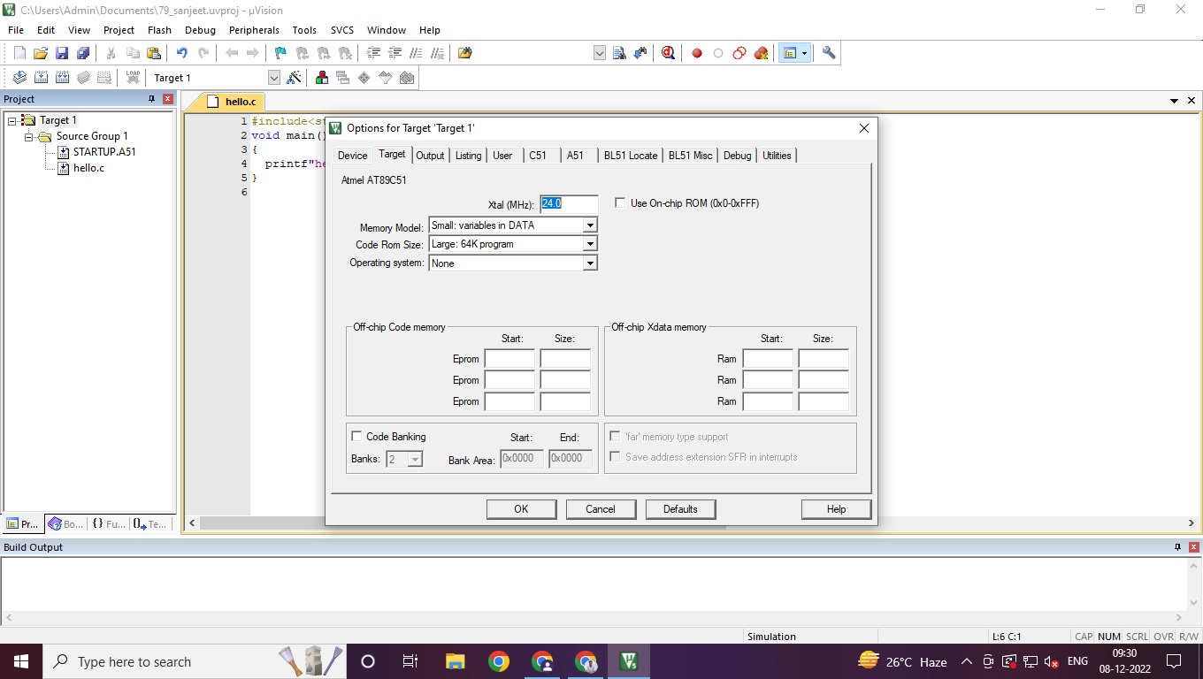

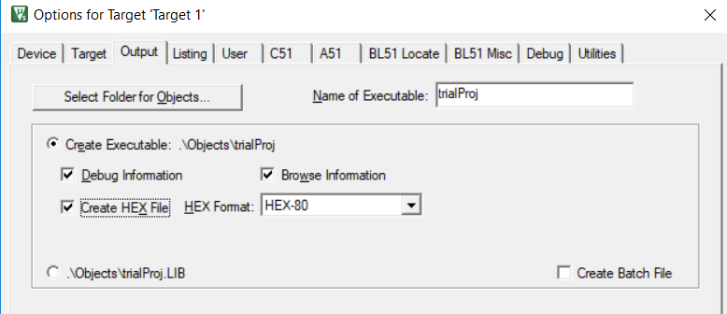

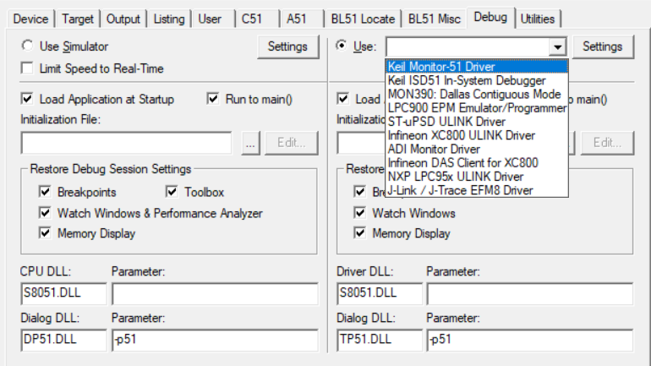

**Now Build the program:**

2nd in the below three icon is **BUILD** icon:

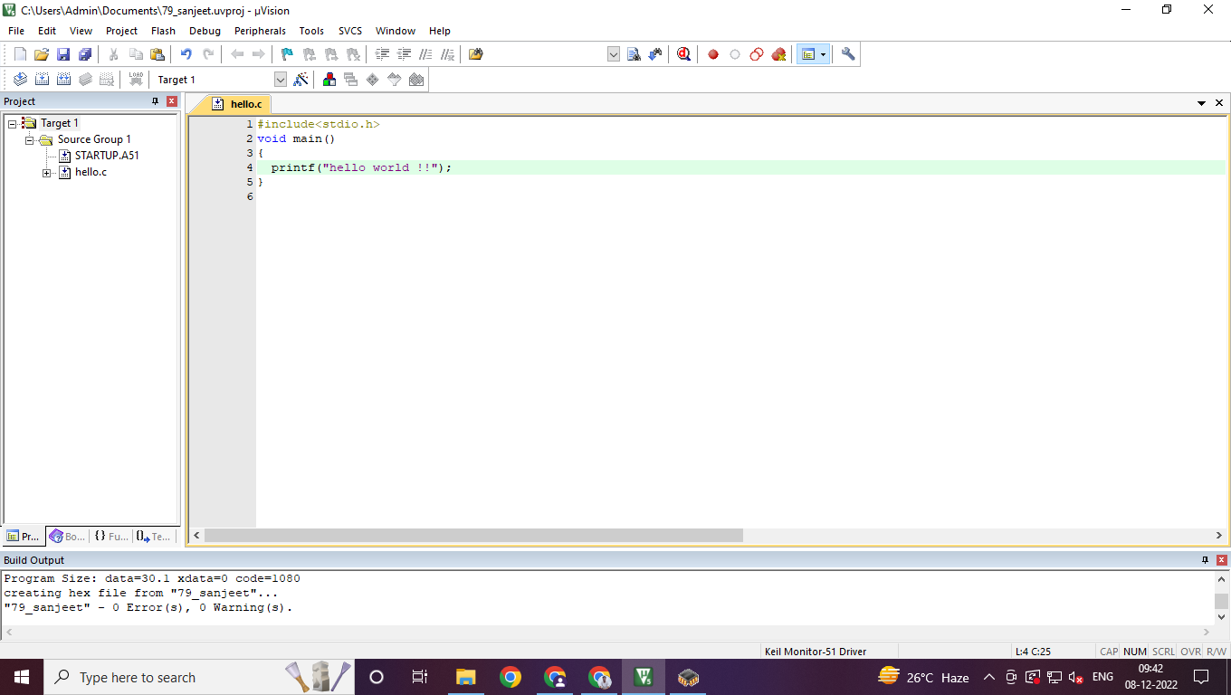

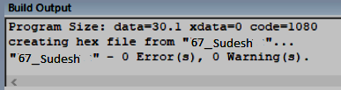

**Using Flash Magic**

Software required to use the hex file in the embedded systems is flash magic. Run the flash magic software.

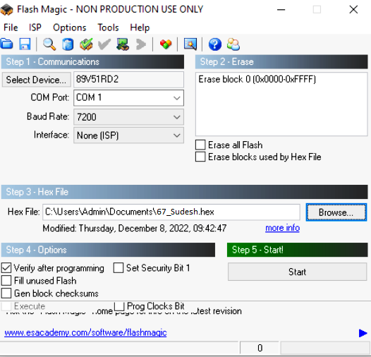

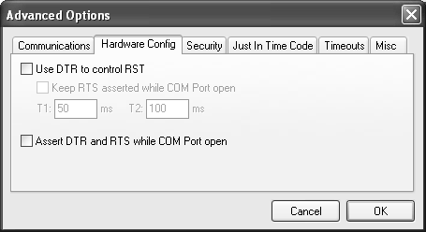

**USE THE FOLL STEPS:**

**Step 1**

Select the communication device as 89V51RD2. This is the NXP microcontroller used for executing the embedded system programs.

**Step 2**

Select the appropriate COM port. If a serial cable is used to connect the TKbase kit to the PC at the default serial port, this would be a COM1 port. It can be checked from control panel – hardware and sound – Device Manager - ports

**Step 3**

Select COM1 and baud rate as 9600.

**Step 4**

Select the default None (ISP) interface.

**Step 5**

From options – Advanced options – hardware config tab, uncheck the marks for use DTR for control RST as well as Assert DTR and RTS while COM port open option.

**Step 6**

Choose to erase all flash memory contents to make place or to load the fresh program into 8051 memory.

**Step 7**

Browse and select the compiled and build program in the form of a hex file.

Choose the verify after programming option in step4. Do not check any other option.

**Step 8**

Connect the TKbase trainer kit with the PC using the relevant port. Use the serial data cable, or USB to serial converter or bridge for this connection. Do necessary hardware connections.

**Step 9**

Give power to the kit. Press the reset button on the kit. Then click on the start button of the flash magic interface as shown above. After the software prompts to reset the device in ISP mode, press reset again.

**Step 10**

Now the hex file is downloaded. Press reset again to execute the downloaded program…or you can see the output in tools->terminal.

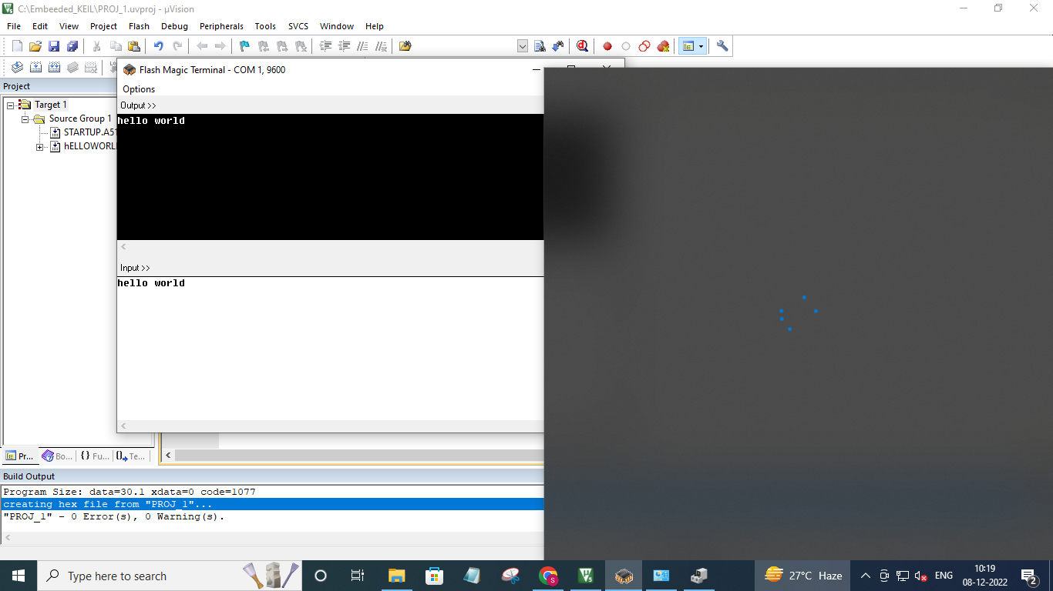

### **Practical 2**

#### PRACTICAL 2a) Configure timer control registers of 8051 and develop a program to

#### generate a given time delay.

**Embedded code:**

| #include <REG51.H>  void T0Delay(void);  void main(void)  {  while (5)  {  P1=0xFF; //make high all bits of port 1  T0Delay();  P1=0x00; // make low all bits of port 1  T0Delay();  }  }  void T0Delay() //delay function  {  TMOD=0x01; // use timer 0 , mode 1  //Load value "FC" in timer 0 lower byte & load //value "65" in timer 0 higher byte for 1 second //delay  TL0=0xFC; // load TL0  TH0=0x65; //load TH0  TR0=1; // turn on Timer 0  while (TF0==0); //wait for TF0(timer 0 overflow flag) to roll //over(overflow)  TR0=0; //turn off timer 0 run control bit  TF0=0; // clear timer 0 overflow flag bit.  } |
| --- |

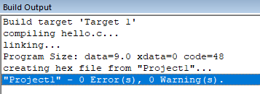

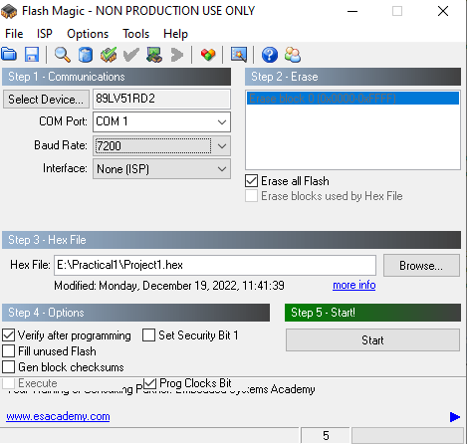

**Steps in Execution**

* Open a suitable development environment and create a new project.
* Add a new C file to the project and save it as timer.c
* Write the appropriate code.
* Build the hex file.
* Use Flash Magic software to load the program in 8051 microcontroller.
* Execute the program and observe output.

Output:

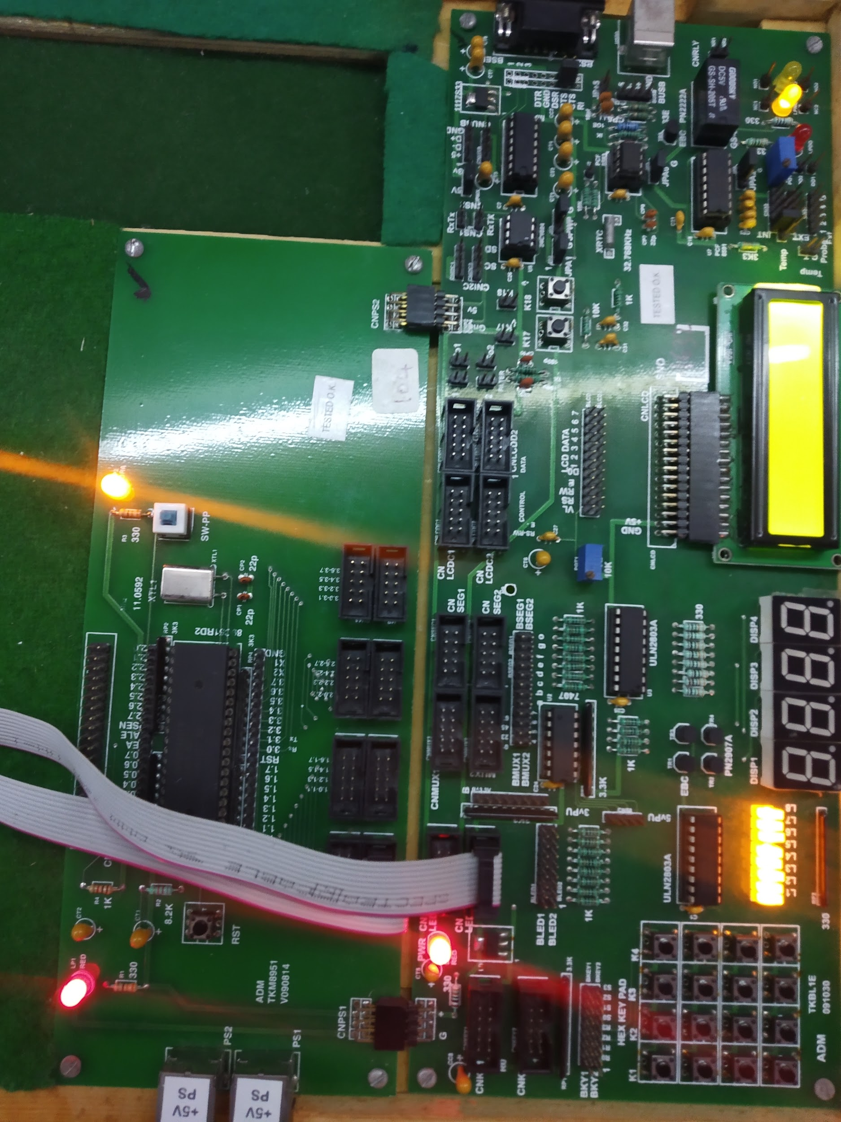

Video:

| <https://drive.google.com/file/d/1VnJ7rA4FE54ik0Nqqgh5PLipd7p-0bWj/view?usp=share_link> |
| --- |

#### Practical 2b) To demonstrate use of general purpose port i.e. Input/ output port of two

#### controllers for data transfer between them.

**Algorithm**

**First Microcontroller**

1. Set Port 2 as the output port.

2. Set a Hex data value at port2.

**Second Microcontroller**

1. Set P1 as input port and port 2 as output port.

2. Redirect input from port 1 to port 2.

**Code**

**Controller 1:**

| **#include<reg51.h>**  **void Delay(unsigned int time);**  **void main(void)**  **{**  **P2 = 0xAA;**  **Delay(1000);**  **P2 = 0x55;**  **Delay(1000);**  **}**  **void Delay(unsigned int time)**  **{**  **unsigned int i,j;**  **for (i = 0; i < time; i++){**  **for (j = 0; j < 23; j++){**  **}**  **}**  **}** |
| --- |

**Controller2:**

| **#include<reg51.h>**  **void Delay(unsigned int time);**  **void main(void)**  **{**  **while(1){**  **P2 = P1;**  **Delay(1000);**  **}**  **}**  **void Delay(unsigned int time)**  **{**  **unsigned int i,j;**  **for (i = 0; i < time; i++){**  **for (j = 0; j < 23; j++){**  **}**  **}**  **}** |
| --- |

**Code 1:**

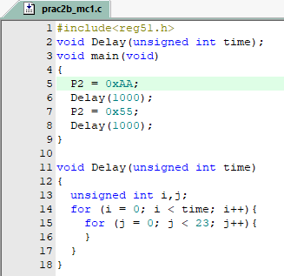

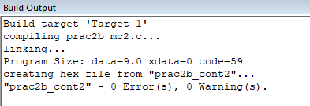

**Code:2**

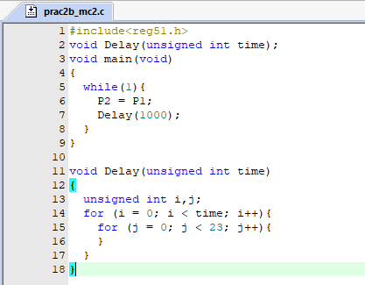



OUTPUT:

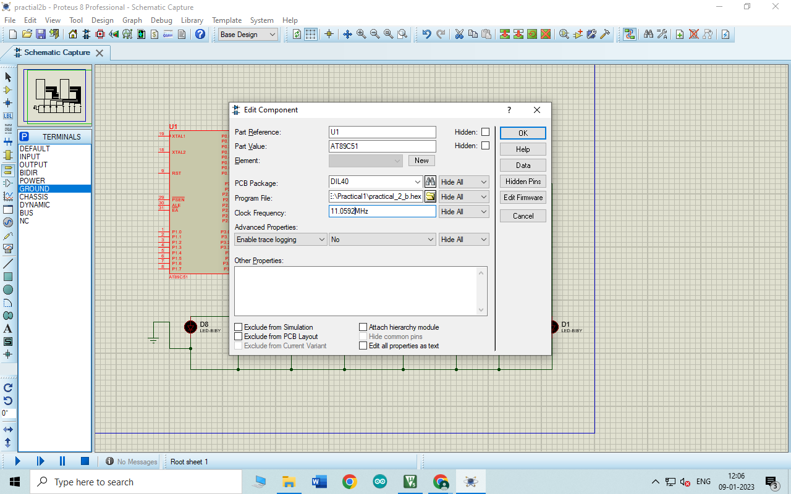

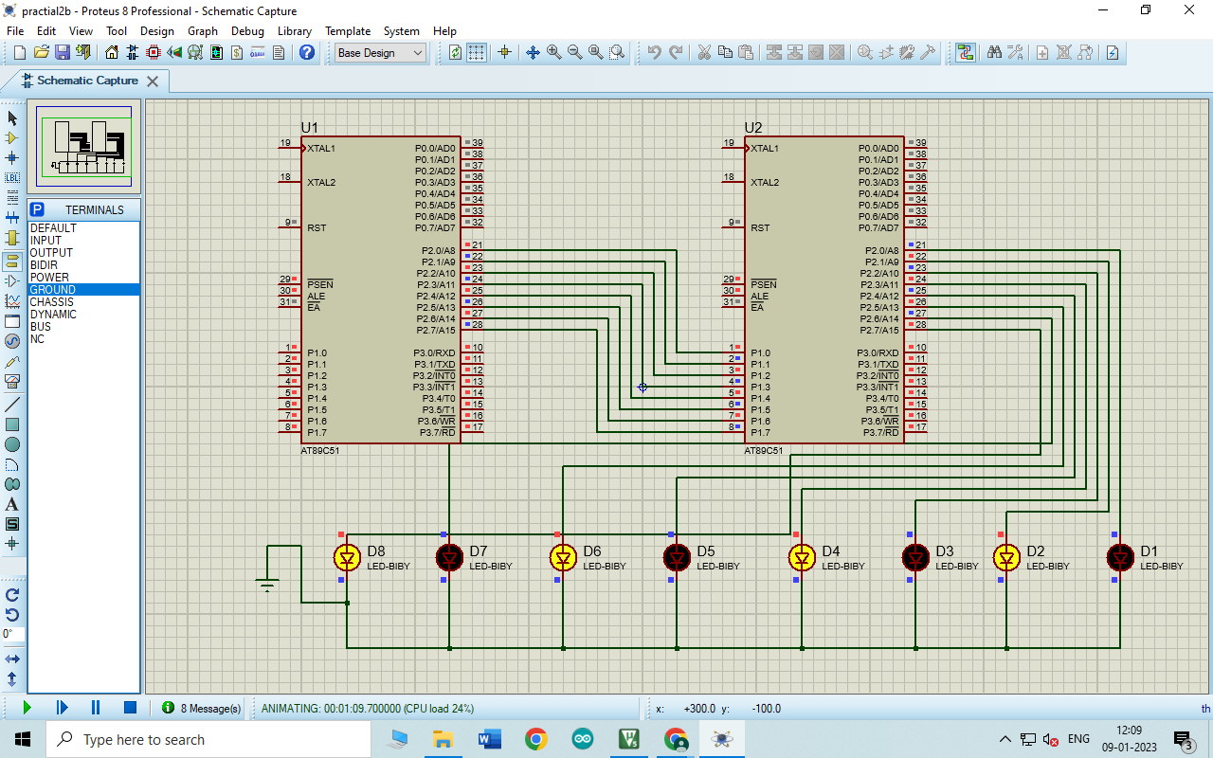

### **Practical 3**

### 

#### Practical 3a)Blink led in continuous loop in arduino IDE.

Arduino Code:

| int ledPin=13;  void setup() {  // put your setup code here, to run once:  pinMode(ledPin,OUTPUT);  }  void loop() {  // put your main code here, to run repeatedly:  digitalWrite(ledPin, HIGH)  delay(1000);  digitalWrite(ledPin, LOW)  delay(1000);  } |
| --- |

Output:

<https://drive.google.com/file/d/1Cj19aenad0_ppGyaG15KL42pAxP0scBz/view?usp=share_link>

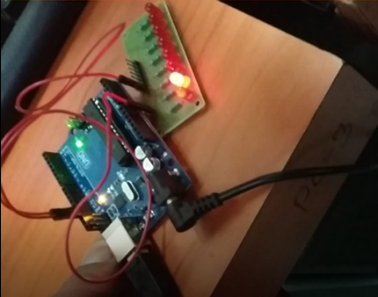

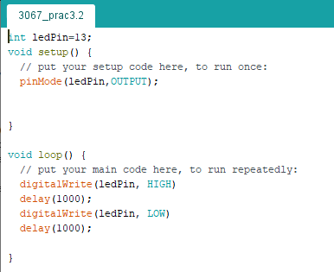

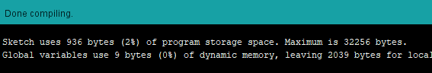

#### Practical 3b)LED blinking slowly( delay) with Arduino. Fade in and fade out.

Arduino Code:

| int led=10;  int brightness=0;  int fade=5;  void setup()  {  pinMode(led,OUTPUT);  }  void loop()  {  analogWrite(led,brightness);  brightness=brightness+fade;  if(brightness<=0||brightness>=255)  {  fade=-fade;  }  delay(30);  } |
| --- |

Output:

<https://drive.google.com/file/d/1DS4pcF9QW-3eCRulFBPkLx-as-WkT8K4/view?usp=share_link>

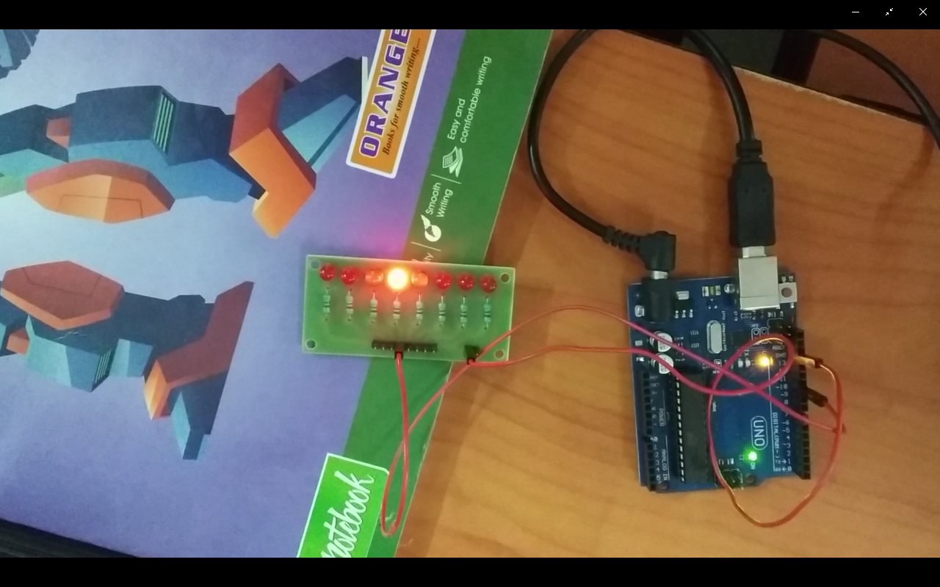

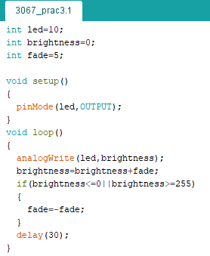

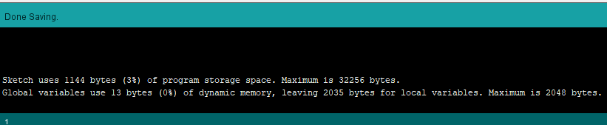

### **Practical 4**

#### 

#### Practical 4 a) Port I / O: Use one of the four ports of 8051 for O/P interfaced to eight LED’s. Simulate binary counter (8 bit) on LED’s

**Problem Definition**

Write an embedded C program to configure Port 1 of 8051 microcontroller as output port. Construct a binary counter output at port 1 of 8051. The counter should start counting from 00 H to FF H. Demonstrate the output using an 8 bit LED interface.

**Algorithm**

1. Initialize port1 as output port.

2. Move the binary data value 00000000 to port1 this will switch off the LEDs connected at port1.

3. Call delay function which will wait for a calculated time interval. 4. Increment the binary value by 1.

5. Call delay

6. Repeat steps 2 – 5 in infinite loop.

Code:

| #include<reg51.h>  void delay(int time);  void main()  {  P1 = 00000000; // Initialize Port 1 as Output Port while(1)  while(1)  {  P1++; // Increment Port 1 (Binary Counter)  delay(100);  }  }  void delay(int time)  {  int i,j;  for(i=0;i<=time;i++)  for(j=0;j<=23;j++);  } |
| --- |

Input:

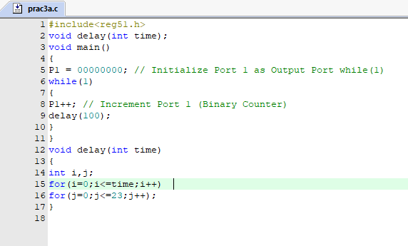

Output:

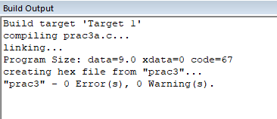

**Video link:**

[**https://drive.google.com/file/d/1rhuxluN0c1uwPw9KuJC05sNOv9nFCSiH/view?usp=sharing**](https://drive.google.com/file/d/1rhuxluN0c1uwPw9KuJC05sNOv9nFCSiH/view?usp=sharing)

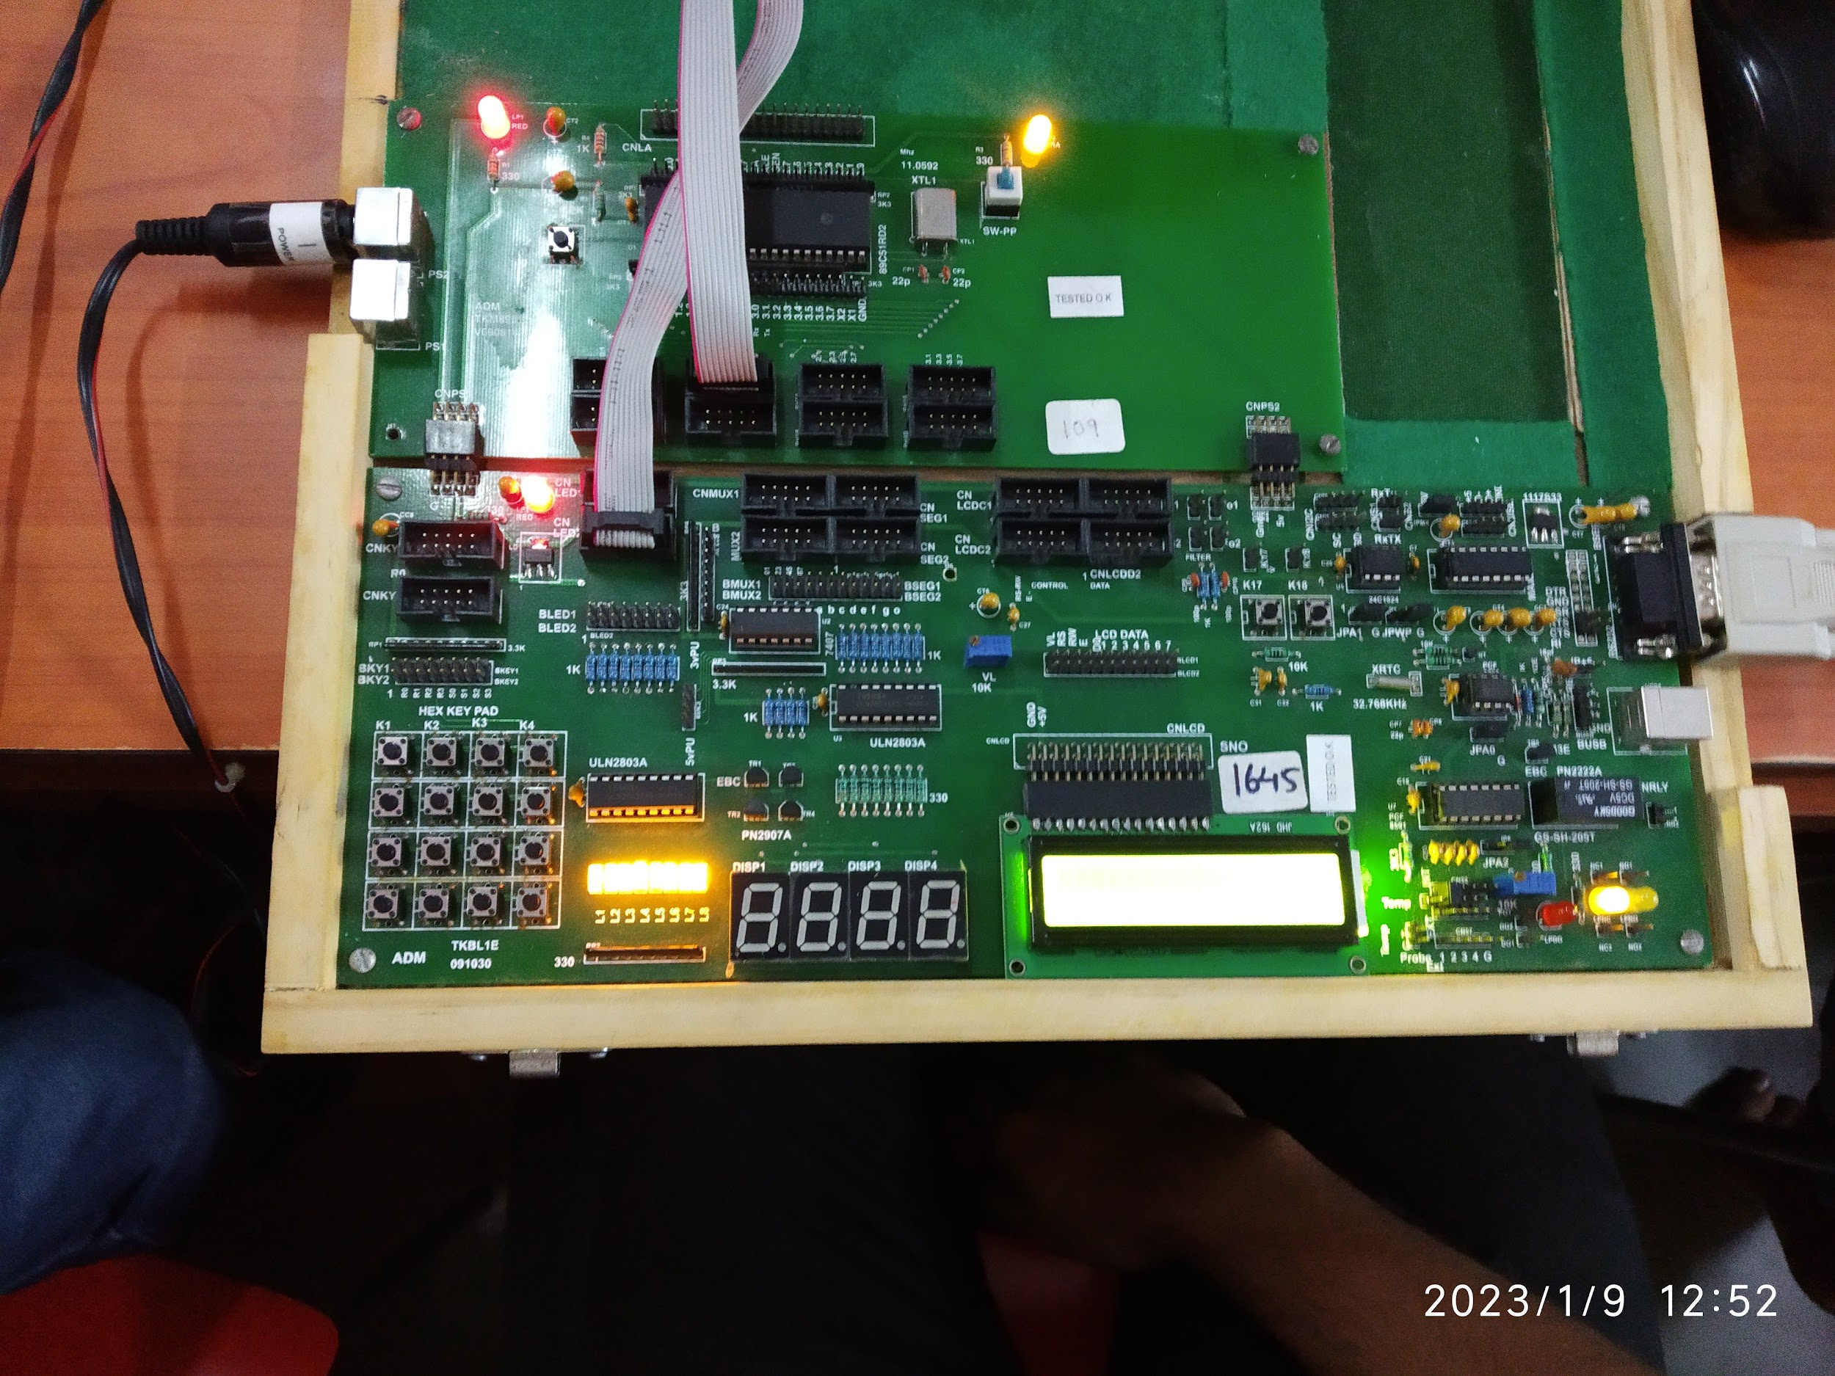

#### 

#### 

#### Practical 4b) To interface 8 LEDs at Input-output ports of 8051 microcontroller and create different patterns.

**Definition**

Configure port 1 of 8051 microcontroller as output port. Connect a 8 bit LED interface at port 1. Write an embedded C program to generate different patterns and display on the LED interface.

**Algorithm**

1. Set port 1 as output port.

2. Call delay.

3. Change pattern.

4. Repeat steps 2 to 4 in an infinite loop.

**Hardware Connections**

**Code**

| #include<REG51.H>  void ToDelay(void); // delay() function prototype  void main(void)  {  while(1)  {  P1=0xAA; // pattern to turn on alternate LEDs  ToDelay();  P1=0x55; // Reverse the sequence.  ToDelay();  }  }  void ToDelay()  {  unsigned int i,j;  for (j =0; j<24; j++)  for(i=0;i<1000;i++);  } |
| --- |

Input:

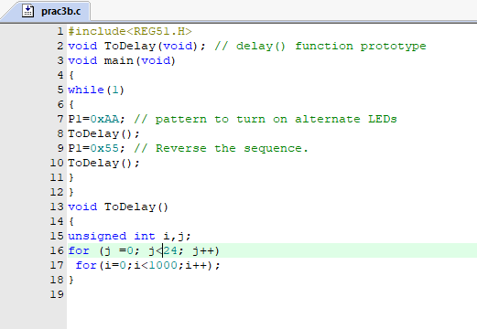

Output:

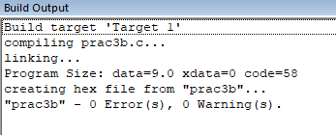

Output:

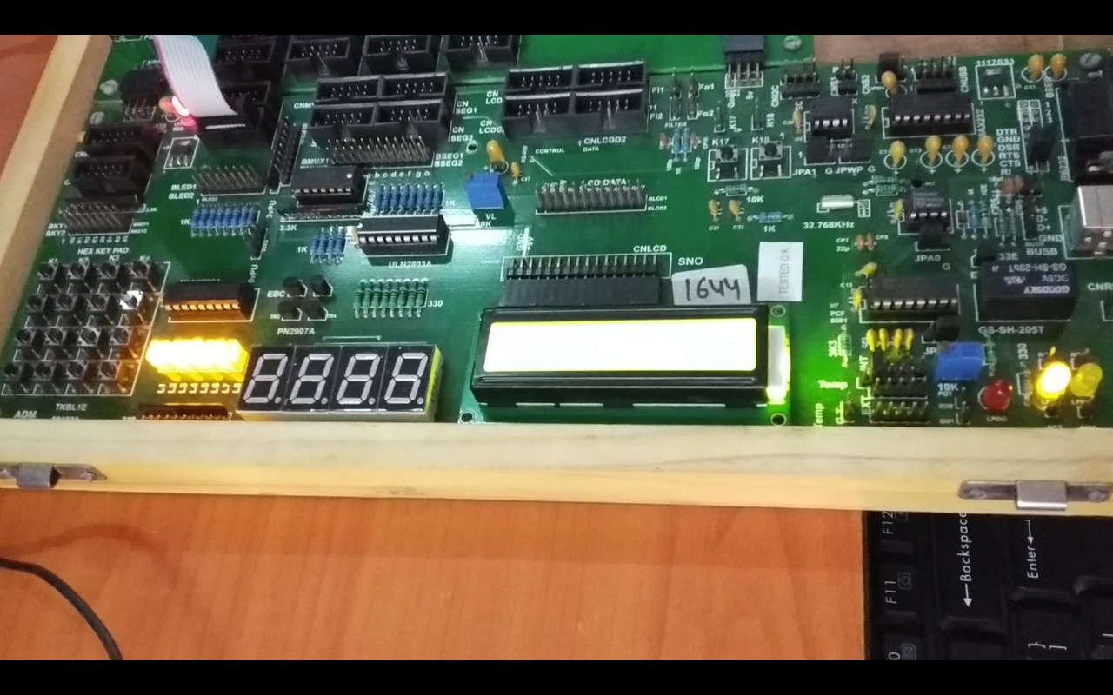

Video link:

<https://drive.google.com/file/d/1s2wIavjSb7PQrW5NzxekVF50gYqLl6rY/view?usp=share_link>

### Practical 5

### 

#### Practical 5 a)Serial I / O: Configure 8051 serial port for asynchronous serial communication with serial port of PC exchange text messages to PC and display on PC screen. Signify end of message by carriage return.

Code:

| #include<reg51.h>  void send(char x); // Prototype of send() function.  void main(void)  {  TMOD = 0x20; // 0x20 is stored in TMOD register to set Timer1 in 8-  //Bit Auto-Reload Mode  TH1 = 0xFD; // TH1 register is loaded with value 0xFD to generate  //baud rate of 9600  SCON = 0x50; // 0x50 is loaded into SCON register to configure  //Timer1 in Mode 1.  TR1 = 1; // When TR = 1.  send('Y');  send('E');  send('S');  while(1);  }  void send(char x) // Send() function transmits the character passed to it  {  SBUF = x;  while(TI==0);  // Wait till transmission is finised i.e. wait until TI = 1  TI=0; // Clear TI flag  } |
| --- |

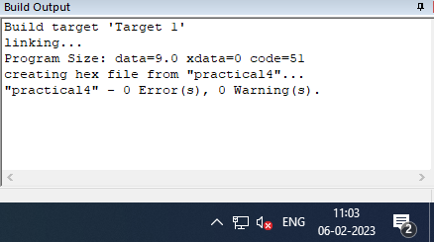

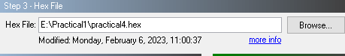

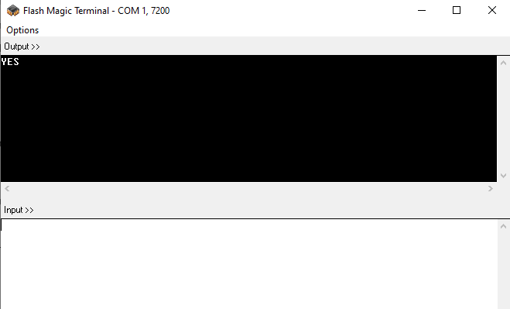

#### 

| send('S');  send('U');  send('D');  send('E');  send('S');  send('H'); |
| --- |

#### 

#### Practical 5 b) To demonstrate interfacing of seven-segment LED display and generate

#### counting from 0 to 99 with fixed time delay.

Code:

| #include <reg51.h>  unsigned char look_up[] = {0X3f, 0X06, 0X5b, 0X4f, 0X66, 0X6d, 0X7d, 0X07,  0X7f, 0X6f, 0X77,0X7c, 0X39, 0X5e, 0X79, 0X71};  //display digit values stored in character array  void delay(int time);  sbit sd0 = P2^0; //defining Port 2.0 to select digit in unit's place in 7-  //segment display  sbit sd1 = P2^1; //defining Port 2.1 to select digit in ten's place in 7-  //segment display  void main()  {  while(1)  {  unsigned char i, j;  for(i=0;i<=5;i++) //loop to display ten's place  {  for(j=0;j<=8;j++) //loop to display one's place  {  sd0 = 1;  sd1=0;  P1 =look_up[i];  delay(500);  sd0 = 0;  sd1 = 1;  P1 = look_up[j];  delay(500);  }}}}  void delay(int time)  {  unsigned int i,j;  for(i=0;i<100;i++)  for(j=0;j<time;j++);  } |
| --- |

**Output**:

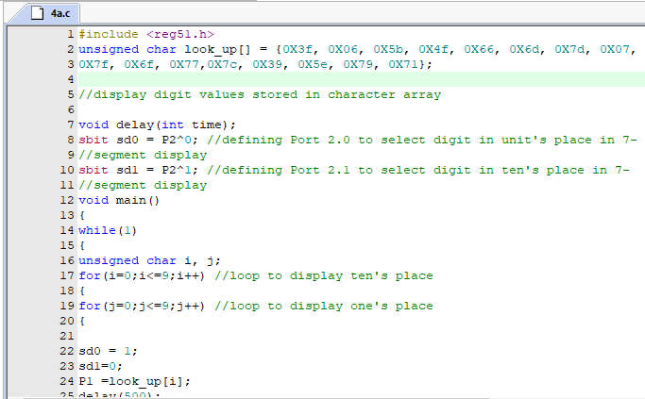

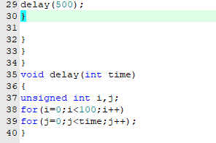

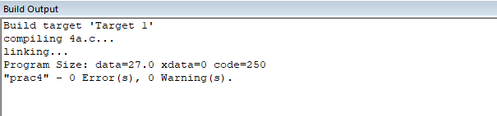

Connections:

| **Bmux 4 and 5 to mc 2.0,2.1**  **Frc port3 to cnseg1** |
| --- |

Output:

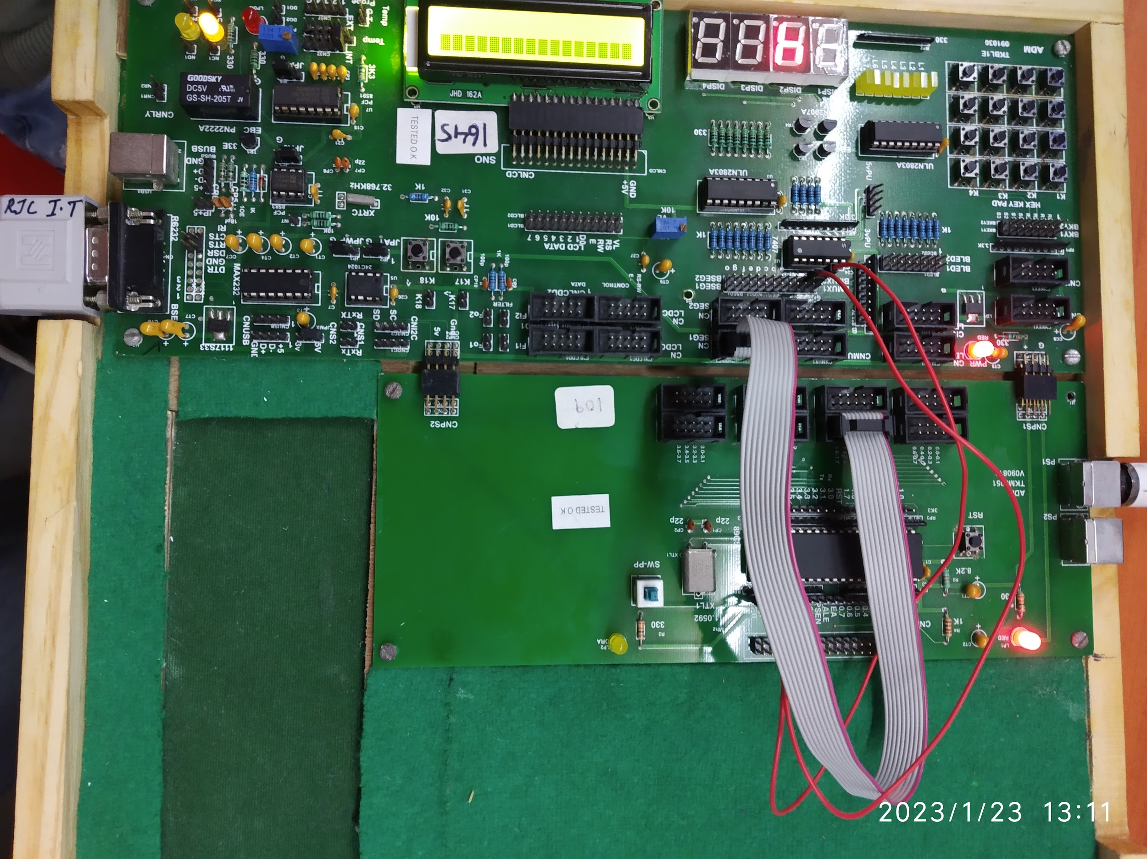

Video:

<https://drive.google.com/file/d/1EVV0bp6avBCK1PaNgXZ8Fom6Lh4wfOWm/view?usp=drivesdk>

#### 

### Practical 6

### 

#### Practical 6a)Interface 8051 with D/A converter and generate square waves of given frequency on an oscilloscope.

**Connections:**

| **Connect A0 and A1 and /WR wires to LOW (GND)**  **Making DAC Enable**  **Connect FRC Cable from port 1 to DATA lines of DAC**  **Connect the CRO with the Output pin of DAC**  **Adjust the CRO setting and you can see the sin Waves on the CRO Display** |
| --- |

Code:

| #include <reg51.h>  void delay(int time);  void main()  {  P1 = 0x00;  while(1)  {  P1 = 0xFF;  delay(1);  P1 = 0x00;  delay(1);  }  }  void delay(int time)  {  int i, j;  for(i = 0; i <= time; i++)  {  for(j = 0; j <= 2; j++)  {    }  }  } |
| --- |

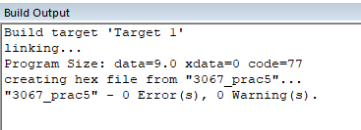

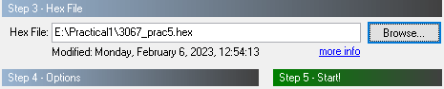

Output:

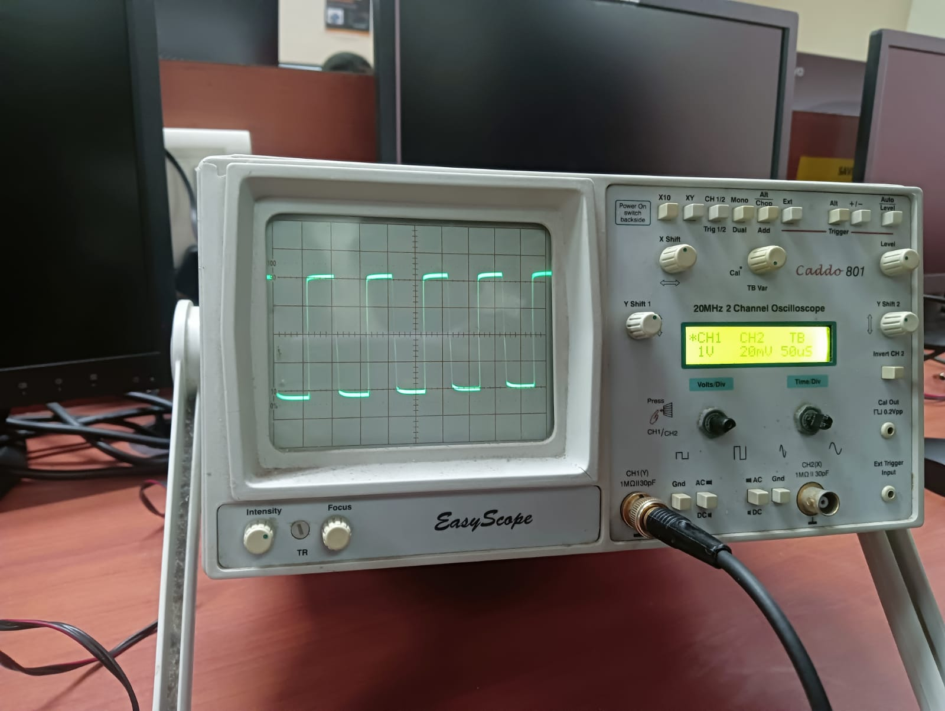

#### Practical 6b)Interface 8051 with D/A converter and generate triangular waves of given frequency on an oscilloscope.

Code:

| #include<reg51.h> //Header file for 8051  void main() // Start of main() function  {  P1 = 0x00; // Initialize Port 1 as Output  while(1) // Infinite Loop  {  do // 1st do-while for upward portion of //triangular wave  {  P1 += 0x05; // Increment P1 to get upward portion  }  while(P1<0xFF); // stop loop after reaching max value  do // 2nd do-while for downward portion of //triangular wave  {  P1 -= 0x05; // Decrement P1to get downward portion  }  while(P1>0x00); // stop loop after reaching lowest value  }  } |
| --- |

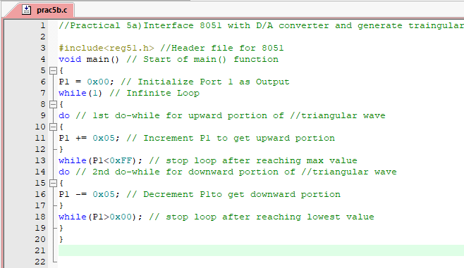

Output:

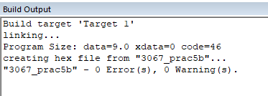

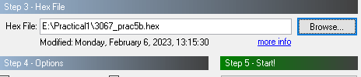

Output:

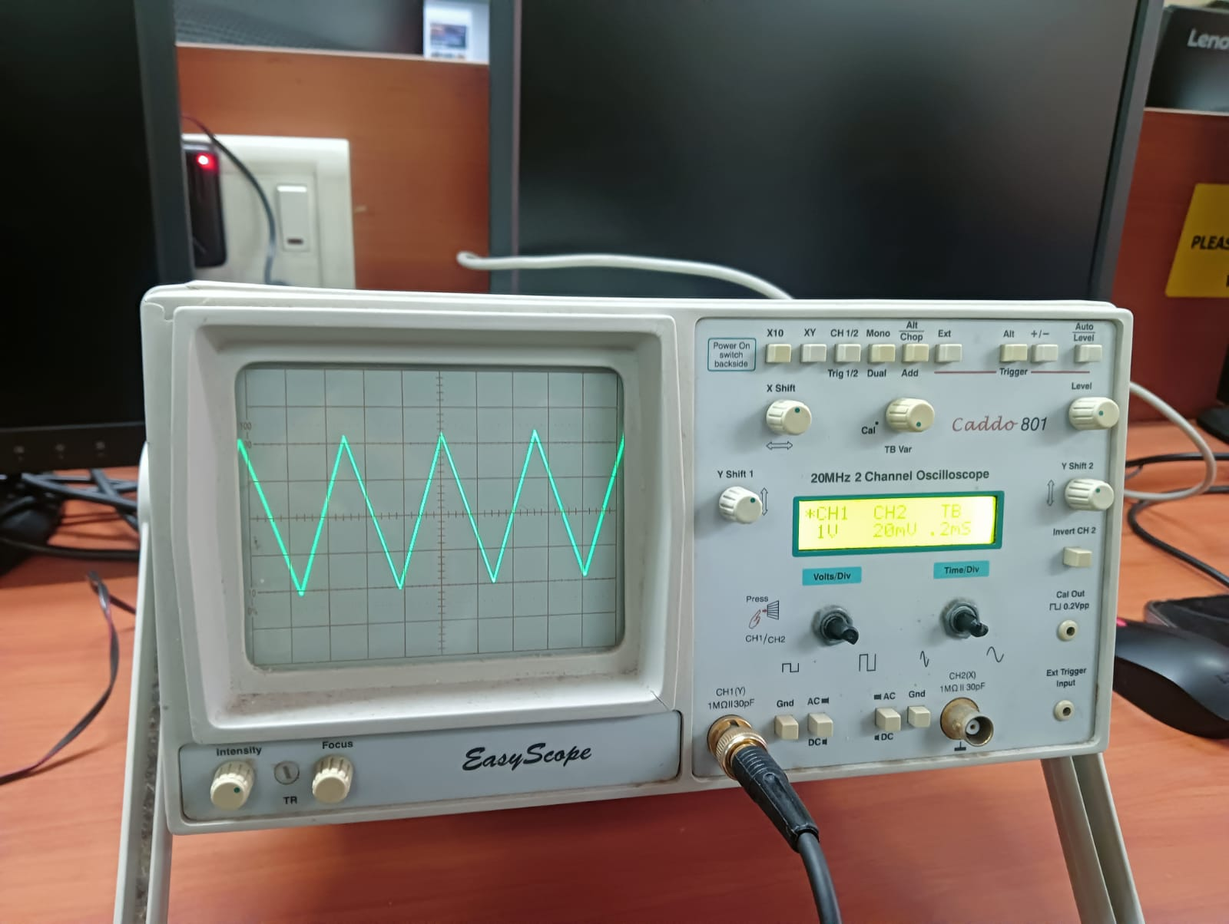

#### Practical 6c)Using D/A converter generates sine waves on an oscilloscope with the help of a lookup table stored in the data area of 8051.

Code:

| #include<reg51.h>  #include<intrins.h> //Header file for NOP function  void main()  {  int WAVEVALUE[12] =  { 128,192,238,255,238,192,128,64,17,0,17,64};  // Create a look-up table (array) named  //WAVEVALUE to send appropriate values to  //DAC so that a sine-wave is generated.  int i;  while(1)  {  for(i=0;i<12;i++)  {  P1 = WAVEVALUE[i];  _nop_();  _nop_(); // _nop_() function introduces delay.  _nop_();  _nop_(); // Repeated use of _nop_() generates  //wave of desired frequency  _nop_0();  _nop_();  }  }  } |
| --- |

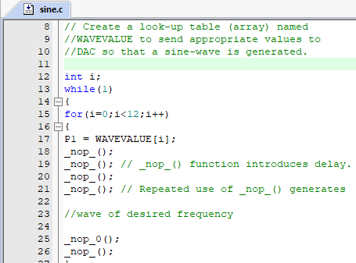

Output:

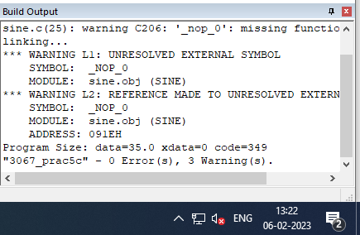

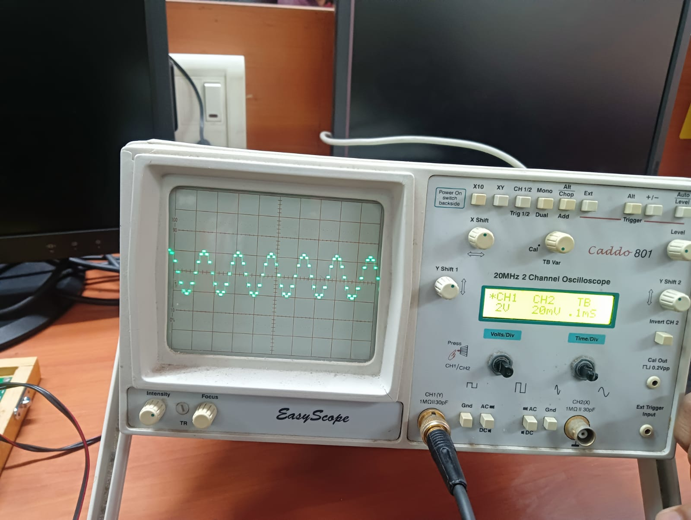

### Practical 7

#### 

#### Practical 7) Interface stepper motor with 8051 and write a program to move the motor through a given angle in clockwise or counterclockwise direction.

CODE:

| #include<reg51.h>  #define stepper P1  void delay()  {  unsigned char i, j, k;  for(i = 0; i < 6; i++)  {  for(j = 0; j < 255; j++)  {  for(k = 0; k < 255; k++);  }  }  }  void main()  {  while(1)  {  stepper = 0x0c;  delay();  stepper = 0x06;  delay();  stepper = 0x03;  delay();  stepper = 0x09;  delay();  }  } |
| --- |

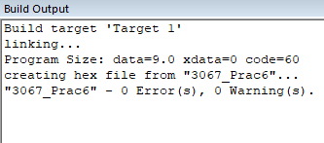

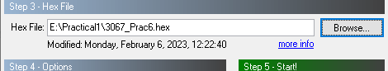

videos:

| <https://drive.google.com/file/d/1XZC0Zh28ZAVWXEkgySUqxBiqhJ-LFNNw/view?usp=sharing>  <https://drive.google.com/file/d/1Xknb9Kr6wksckcp3tXT3mtidGyznEvcw/view?usp=sharing> |
| --- |

Photo:

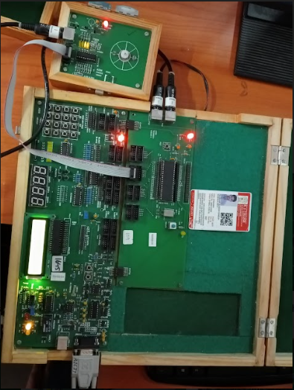

### Practical 8

#### Practical 8) Following dig shows traffic lights on an interface road. There are four lanes and each lane has a traffic signal with Red, Orange and Green light. Lane1 and lane should work simultaneously and Lane3 and Lane4 should work simultaneously.Write a program in embedded C language to control a traffic light on an interface.

Code:

| #include<reg51.h>  #define Lane1Red 0x01 // Define a labels for each combination of colour  //and lane. 4 lanes and 3 colors- 12 labels  #define Lane1Orange 0x02  #define Lane1Green 0x04  #define Lane2Red 0x08  #define Lane2Orange 0x10  #define Lane2Green 0x20  #define Lane3Red 0x01  #define Lane3Orange 0x02  #define Lane3Green 0x04  #define Lane4Red 0x08  #define Lane4Orange 0x10  #define Lane4Green 0x20  sbit Lane1Set = P1^6; // Here the label 'Lane1Set' is used to refer pin  //PORT1.6  sbit Lane2Set = P1^6;  sbit Lane3Set = P1^7; // When the Value is sent to Port1 it needs to be  //latched  sbit Lane4Set = P1^7; // Each Lane has its own port pin to latch the data  // Latching of data is done by sending a Low to  //High signal on the respective Lane pins  void Reset();  void showLane12();  void showLane34();  void SetLane1();  void SetLane2();  void SetLane3();  void SetLane4();  void delay(int time);  void main()  {  Reset(); // Reset the Traffic Light Kit (clear previous data)  while(1)  {  showLane12 (); // Display Traffic lights of Lane 1,Lane 2  Reset ();  showLane34 (); // Display Traffic lights of Lane 3,Lane 4  Reset ();  }  }  void Reset()  {  P1 = 0x00; // Turn off all LEDs  delay (100);  Lane1Set = Lane2Set = 1; // Latch data 0x00 to lane 1 & lane 2  Lane3Set = Lane4Set = 1; // Latch data 0x00 to lane 3 & lane 4  }  void showLane12() // this function will turn on LEDs of Lane 1 and 2  {  P1 = Lane1Green; // send data to Port1 to turn on Green LED of  //Lane1  SetLane1(); // Latch data into the kit.Green LED of Lane1 will  //now turn on  P1 = Lane1Orange;  SetLane1();  P1 = Lane1Red;  SetLane1();  P1 = Lane2Green;  SetLane2();  P1 = Lane2Orange;  SetLane2();  P1 = Lane2Red;  SetLane2();  }  void showLane34() // this function will turn on LEDs of Lane3 & 4 one  //by one  {  P1 = Lane3Green; // send data to Port1 to turn Green LED of L3  SetLane3(); // Latch data into the kit. Green LED of Lane 3 will  //now turn on  P1 = Lane3Orange; // Repeat the steps for all the LEDs on Lane 3 & 4  SetLane3();  P1 = Lane3Red;  SetLane3();  P1 = Lane4Green;  SetLane4();  P1 = Lane4Orange;  SetLane4();  P1 = Lane4Red;  SetLane4();  }  void SetLane1() // This function Latches the data to Lane 1 of the  //kit which was sent on Port1  {  Lane1Set = 0; // 'Lane1Set' i.e pin P1.6 is set to Low  Lane1Set = 1; // 'Lane1Set' i.e pin P1.6 is set to High  delay(2000); // A low to high signal will latch the data  }  void SetLane2() // This function Latches the data to Lane2 of the kit  //which was sent on Port1  {  Lane2Set = 0; // 'Lane2Set' i.e pin P1.6 is set to Low  Lane2Set = 1; // 'Lane2Set' i.e pin P1.6 is set to High  delay(2000); // A low to high signal will latch the data  }  void SetLane3() // This function Latches the data to Lane3 of the kit  //which was sent on Port1  {  Lane3Set = 0; // 'Lane3Set' i.e pin P1.7 is set to Low  Lane3Set = 1; // 'Lane3Set' i.e pin P1.7 is set to High  delay(2000); // A low to high signal will latch the data  }  void SetLane4() // This function Latches the data to Lane4 of the kit  //which was sent on Port1  {  Lane4Set = 0; // 'Lane4Set' i.e pin P1.7 is set to Low  Lane4Set = 1; // 'Lane4Set' i.e pin P1.7 is set to High  delay(2000); // A low to high signal will latch the data  }  void delay(int time)  {  int i,j;  for(i=0;i<=time;i++)  for(j=0;j<=23;j++);  } |
| --- |

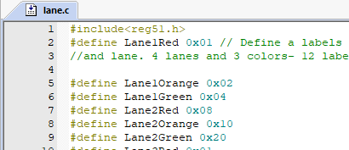

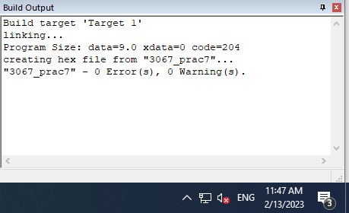

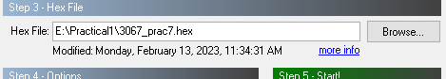

Output:

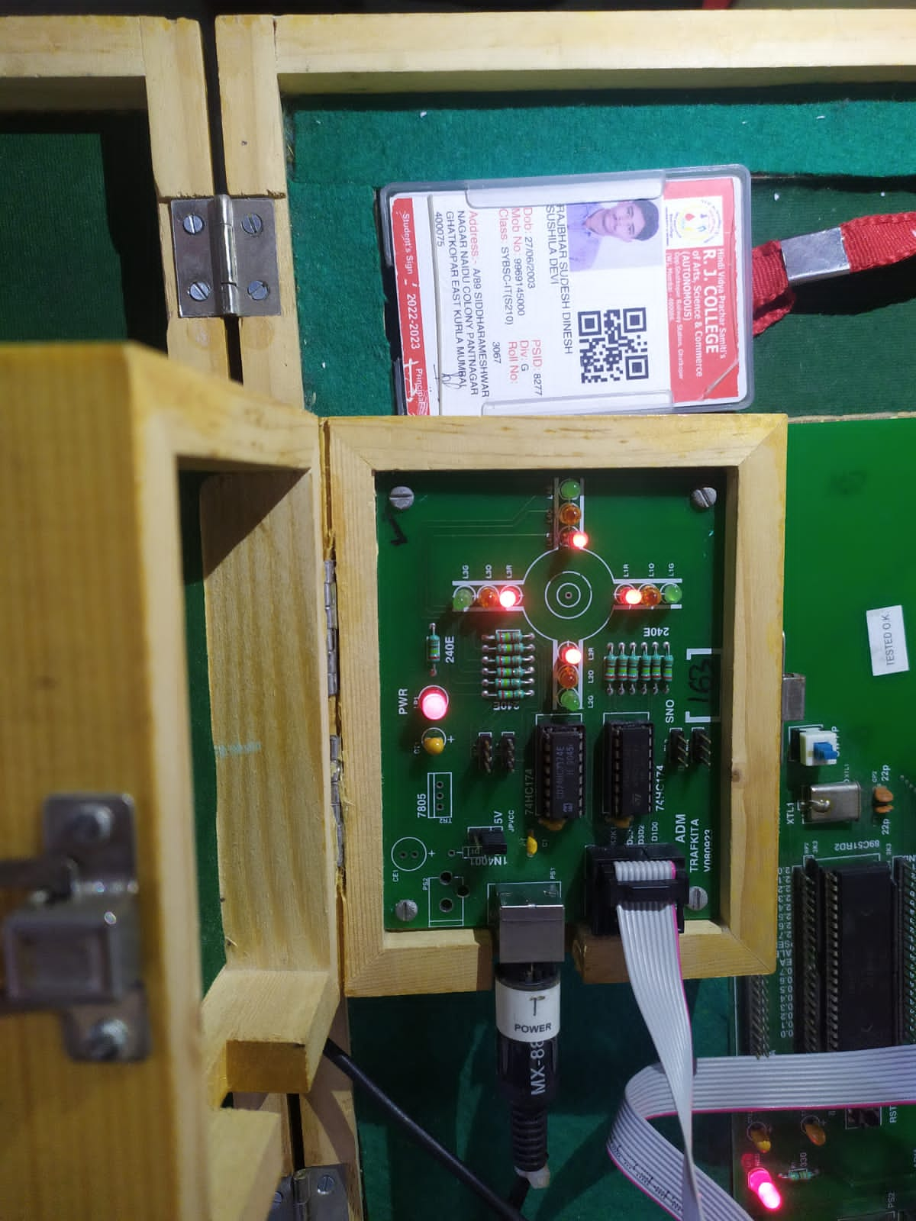

Video link:

<https://drive.google.com/file/d/1e_U-i-0nl3MWlw4hA9WF4pGbZl0B7ZB7/view?usp=sharing>

### Practical 9

#### Practical 9) Write a program in embedded C language to simulate an elevator control system using a stepper motor. System includes a keypad to key in the floor, a seven segment display to show the current position of the elevator and a stepper motor which would act as the elevator itself.

Code:

| #include <reg51.h>  unsigned char newkey,oldkey,p; //newkey variable is for newly pressed  //key; oldkey variable is to store the  //previous pressed key;  //p variable acts as a pointer.  signed char tmp; //tmp variable is to store the difference  //between oldkey and newkey pressed  sbit sd = P2^0; //Defining P2.0 bit as an sd;  unsigned char look_up[]={0x3f,0x06,0x5b,0x4f,0x66,  0x6d,0x7d,0x07,0x7f,0x6f,0x77,0x7c,0x39,0x5e,0x79,0x71};  unsigned char motor_sequence[]={8,4,2,1,8,4,2,1,8,4,2,1,8,4,2,1};  void key_scan (void); //Scan keyboard and check whether the key  //is pressed?  void get_key (void); //Get the pressed key code  void display (unsigned char); //Display pressed key and also rotate motor  void delay (unsigned int time);  void main (void)  {  P0=0xf0;  while (1)  {  key_scan ();  get_key ();  }  }  void key_scan (void)  {  oldkey=newkey; //stores previously pressed key in oldkey  while (1)  {  P0=0xFE; //Make 1st row ground  P0 &=0xFE; //Check whether key is pressed in the 1st row?  if (P0!=0xFE) //if yes then  break; //Come out of loop, else  P0=0xFD; //Make 2nd row ground  P0 &=0xFD; //Check whether the key is pressed in 1st row?  if (P0!=0xFD) //if yes then  break; //Come out of loop, else  P0=0xFB; //Make 3rd row ground  P0 &=0xFB; //Check whether the key is pressed in the 1st row?  if (P0!=0xFD) //if yes then  break; //Come out of loop, else  P0=0xF7; //Make 4th row ground  P0 &=0xF7; //Check whether the key is pressed in 1st row?  if (P0!=0xF7) //if yes then  break;//Come out of loop, else  }  newkey=P0; //Store keycode in newkey variable do {  do  {P0=0xF0; //Again initialize P0 to its default value this //will allow user to press next key  }  while (P0!= 0xf0);  }  void get_key (void)  {  if (newkey==0xee)  display (0);  else if (newkey==0xed)  display (1);  else if (newkey==0xeb)  display (2);  else if (newkey==0xe7)  display (3);  else if (newkey==0xde)  display (4);  else if (newkey==0xdd)  display (5);  else if (newkey==0xdb)  display (6);  else if (newkey==0xd7)  display (7);  else if (newkey==0xbe)  display (8);  else if (newkey==0xbd)  display (9);  else if (newkey==0xbb)  display (10);  else if (newkey==0xb7)  display (11);  else if (newkey==0x7e)  display (12);  else if (newkey==0x7d)  display (13);  else if (newkey==0x7b)  display(14);  else if (newkey==0x77)  display(15);  }  void display (unsigned char x)  {  newkey=x;  tmp=newkey-oldkey; //Take the difference between newkey and //previously pressed key  sd=0; //Select the display  if (tmp<0x00) //if tmp value is less than zero it //indicates that the newkey pressed is  //smaller than the previous key pressed  {  for (p=oldkey;p>newkey;p--)  {  P3=motor_sequence[p]; //motor will rotate in steps  //depends on tmp value, anti-clockwise  P1=look_up[p]; //displays value on seven segment  delay (10000);  }  P3=motor_sequence[p]; //motor will rotate once in anticlockwise P1=look_up[p];  delay (10000);  }  else  {  for (p=oldkey;p<newkey;p++)  {  P3=motor_sequence[p]; //motor will rotate in steps depends on  //tmp value, clockwise  P1=look_up[p]; //displays value on seven segment  delay (10000); //software delay  }  P3=motor_sequence[p]; //motor will rotate once, clockwise  P1=look_up[p];  delay (10000);  }  }  void delay (unsigned int time)  {  unsigned int i;  for (i=0;i<=time;i++);  } |
| --- |

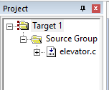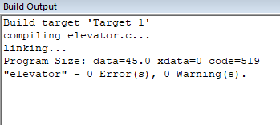

Connection:

1. Connect FRC Cable "PO" to Hex keypad (CNKY1) For taking Input from the Hex Keypad
2. Connect FRC Cable "P1" to Seven Segment Display (CNSEG1) To Display Floor Number
3. Connect Cable BMUX2 (pin 4) to microcontroller port 2.0 For Selecting Display Device
4. connect FRC Cable from port 3 of Microcontroller to the Stepper Motor to provide Input to Stepper Motor
5. After pressing Hex keypad Buttons you can see seven segment Display Indicating Floors and Stepper motor Rotating
6. Pressing F key on HexKeypad Motor will move Clockwise Elevator reached Top Floor
7. Pressing C key on HexKeypad, Motor will rotate four steps in reverse direction Elevator reached 12th floor

